Level 3 Install, configure and upgrade ICT software

(7540-362/7630-335)

Scenario
You work as a support technician in a large call centre and you have been tasked with setting up a workstation for a new manager. All of the physical connections have been made and you have been told that the allocated hardware is adequate for the job.
You need to install a client operating system, set up a network user account and install some application software before handing the workstation to the manager. All of the application software for installation is held on a central server and needs to be installed over the network.
The client operating system is to be installed from removable media.
Your manager has asked you to keep records of all relevant details of the installation so that they can be entered on the central support database.

Task A – Plan and prepare for software installation

1 Using the workstation’s BIOS, record the hardware specification and system configuration of the workstation on your installation record.
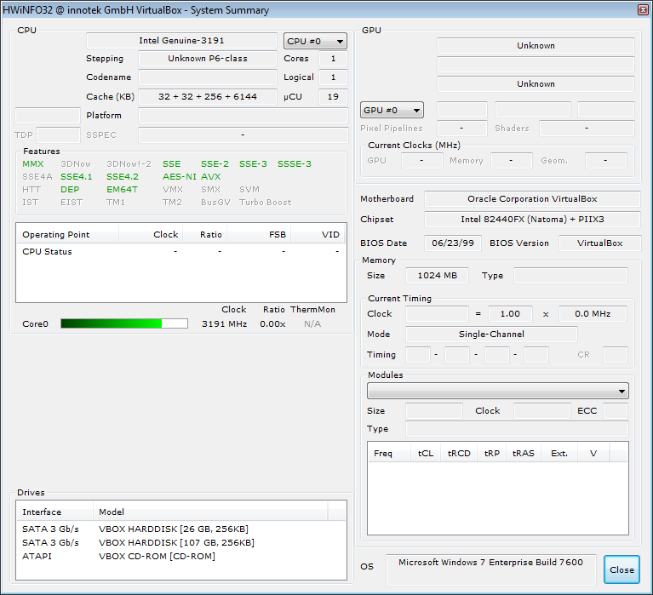
1.A Hardware Specifications from hw32_361 application.
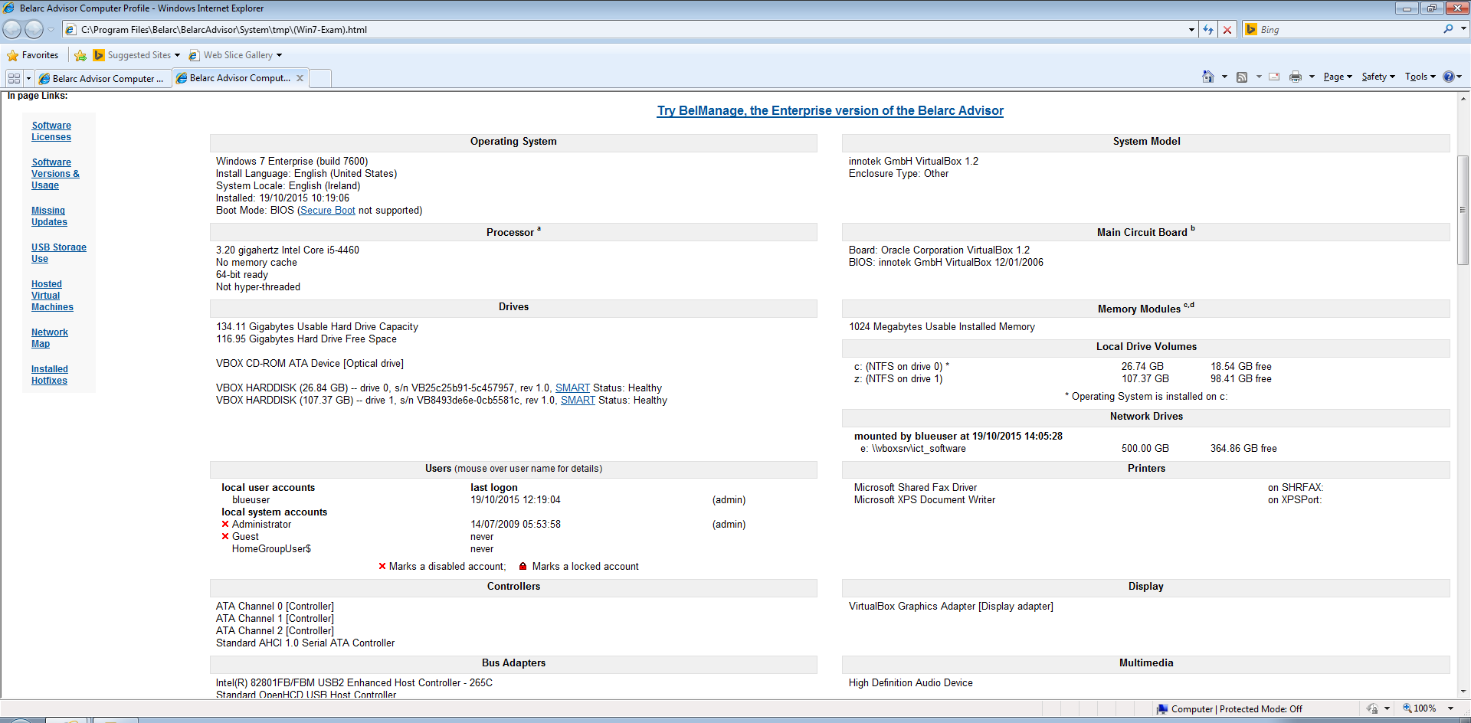
1.B System configuration from Belarc Advisor
[Current Computer]
 | Computer Name: |  |  | WIN7-EXAM
 | Computer Brand Name: |  |  | innotek GmbH VirtualBox
[CPU Unit Count]
 |  | Number Of Processor Packages (Physical): | 1
 |  | Number Of Processors Cores: | 1
 |  | Number Of Logical Processors: | 1

[Motherboard]
 |  | Motherboard Model: | Oracle Corporation VirtualBox
 |  | Motherboard Chipset: | Intel 82440FX (Natoma) + PIIX3
[General information]
 | Total Memory Size: |  |  | 1 GByte
 | Total Memory Size [MB]: |  |  | 1024

2 Record the Operating System type, version number and any service packs installed.
Operating System | Operating System Type | Version | Service Packs
Windows 7 | Windows 7 Enterprise (build 7600) | Evaluation | None

3 Identify and record any software applications installed.
Publisher | Title and Version | Configuration Settings
VirtualBox | Guest Additions | Default Settings
Apache | OpenOffice 4.1.1 | Default Settings
Microsoft | Security Essential 4.8.204.0 | Default Settings
Malware Bytes | Malware Bytes 2.1.8.1057 | Default Settings

4 Identify any existing data residing on the workstation and make a backup copy.
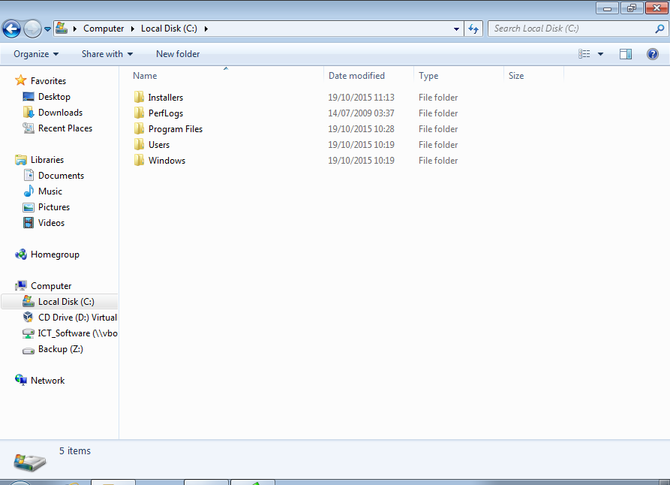
4.A Default installation with almost no data residing on the workstation, except for ‘Installers folder’ needed to setup the workstation.
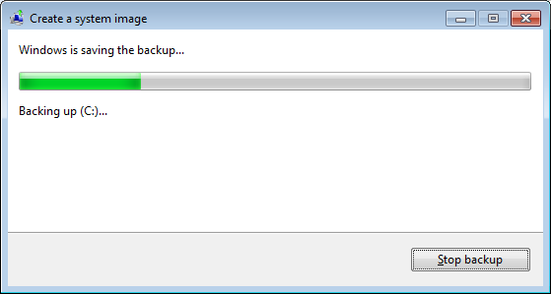
4.B Creating a system image backup.
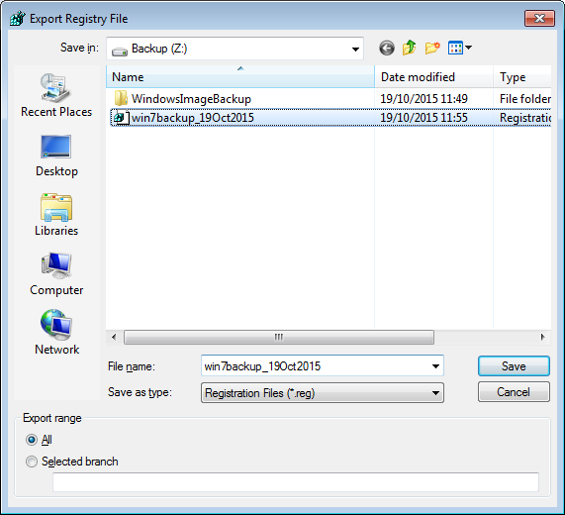
4.C Creating a registry backup.

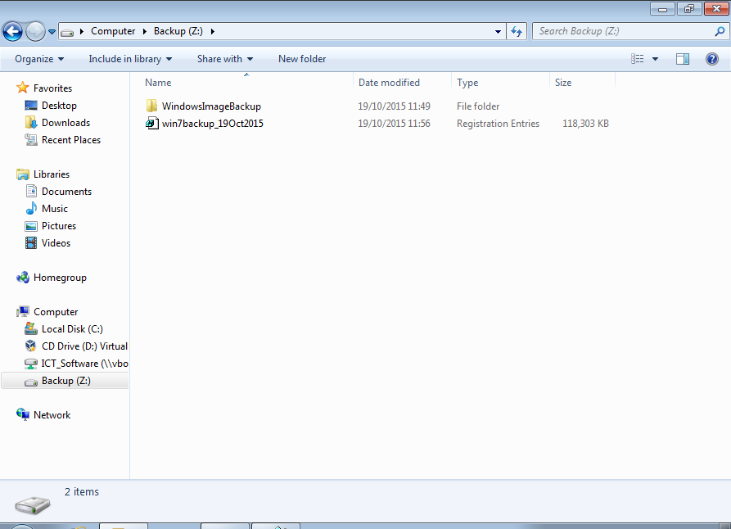
4.D Windows and registry backup completed.

Scan the backup for viruses/malware.
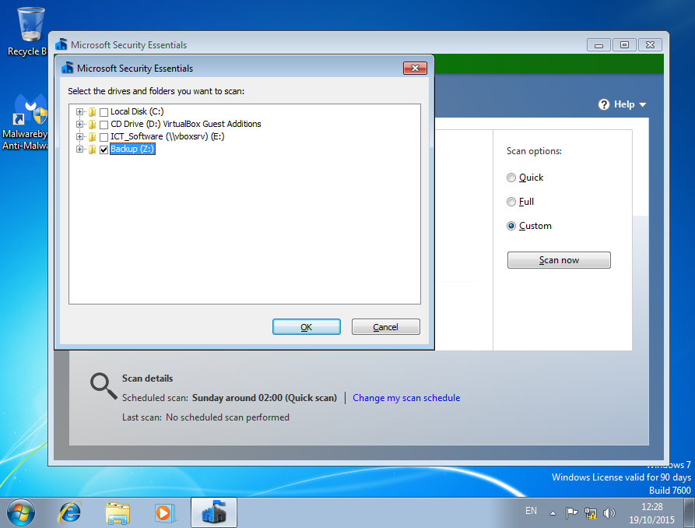
4.E Selecting Backup (Z:) for virus scan.

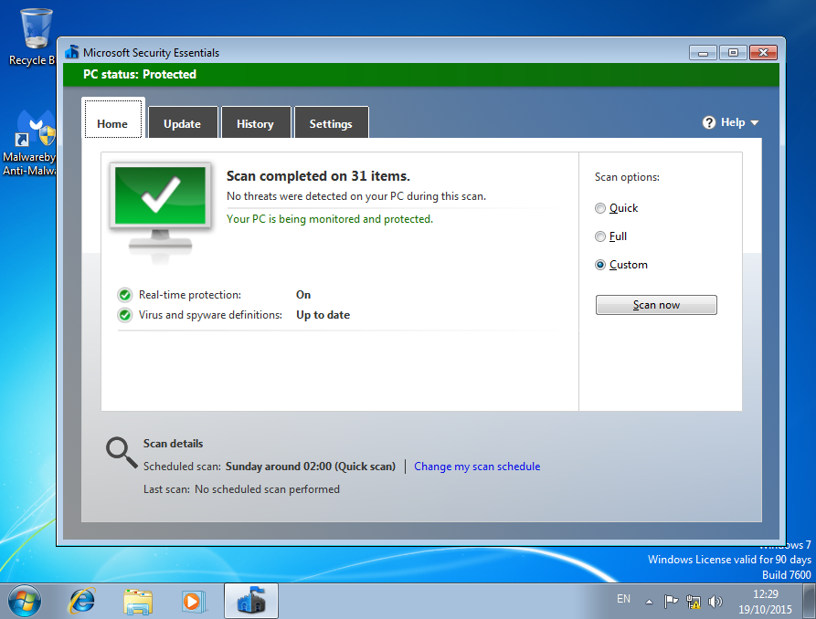
4.F Virus scan completed successfully.

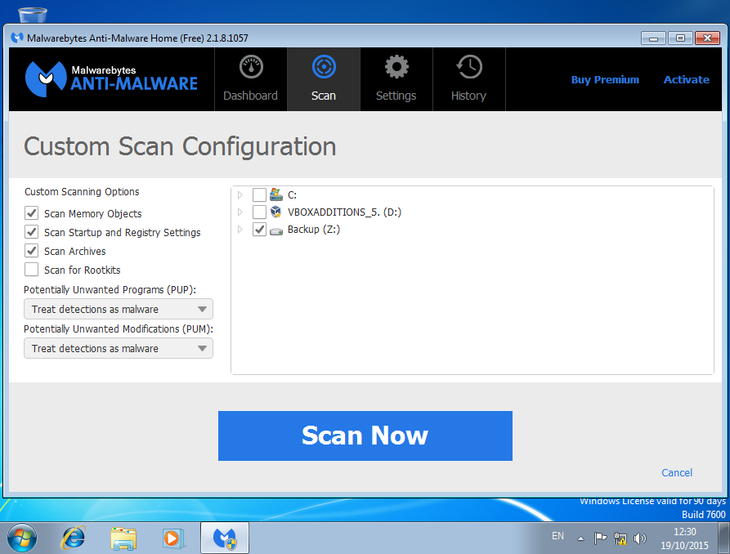
4.G Selecting Backup (Z:) for malware scan.

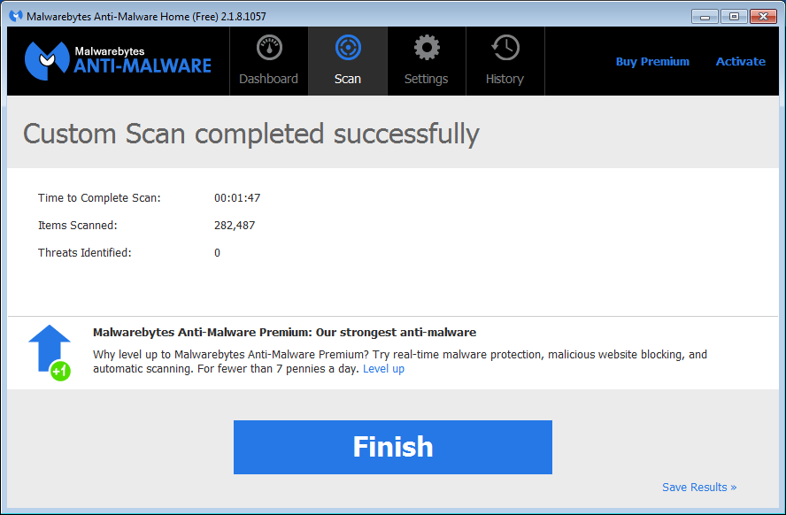
4.H Malware scan completed successfully.

5 From the software list supplied by the assessor, make a record of the software applications and operating system you are going to install noting the:

Publisher | Title and Version | License Type | License Details | Configuration Settings | MSR
Apache | OpenOffice 4.1.1 | GNU | Open Source | Default Settings | 256MB Ram  440 MB available disk space
Microsoft | Security Essential 4.8.204.0 | Proprietary license | Freeware provided the OS is Windows Genuine certified | Default Settings | CPU 1.0 GHz  1 GB RAM  140 MB available disk space
Malware Bytes | Malware Bytes 2.1.8.1057 | Freeware | Freeware | Default Settings | CPU 800MHZ  256 MB RAM  20 MB available disk space
Microsoft | Windows 7 | Evaluation | 10-day trial  extended to 90-days | Default Settings | CPU 1.0 GHz  1 GB RAM  16 GB available disk space

6 Identify any failure to meet the manufacturer’s MSR. Obtain and install appropriate components to rectify the problem.
No failures were identified.
Virtual machines were created with 1GB RAM available, to avoid these types of issues.

7 Produce an installation and test plan for the software stating the:

Identify the resources required for the installation and ensure they are suitable.
Software Name | Order of installation | Type of installation | Installation file location | Post-Installation checks | System Capacity Checks | License key/Registration requirement
Windows 7 OS | #1 | Default | C:\windows | Installed correctly | No issues | Activated Windows Evaluation
Microsoft Security Essentials | #2 | Default | C:\program files | Installed correctly | No issues | Windows genuine authentication
Malware Bytes | #3 | Default | C:\program files | Installed correctly | No issues | N/A
Apache OpenOffice | #4 | Default | C:\program files | Installed correctly | No issues | N/A
See Task B5, hardware meets minimum specification requirements for all software.

Task B – Install, configure and record software installation

1 Install, configure and test the client Operating System using the settings provided by the Assessor.
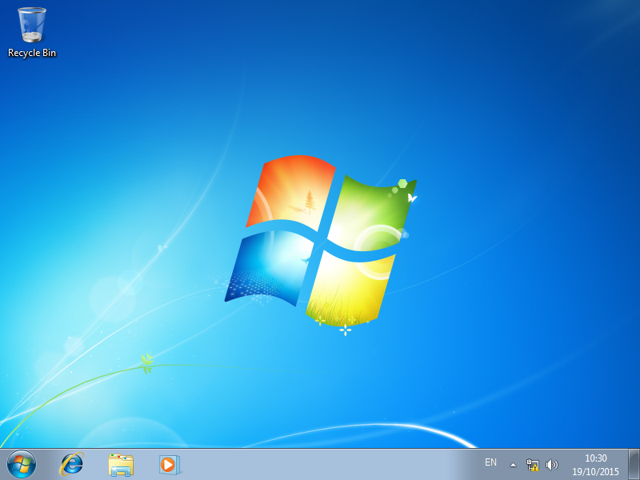
1.A Clean install of Windows 7 for the client Operating System.

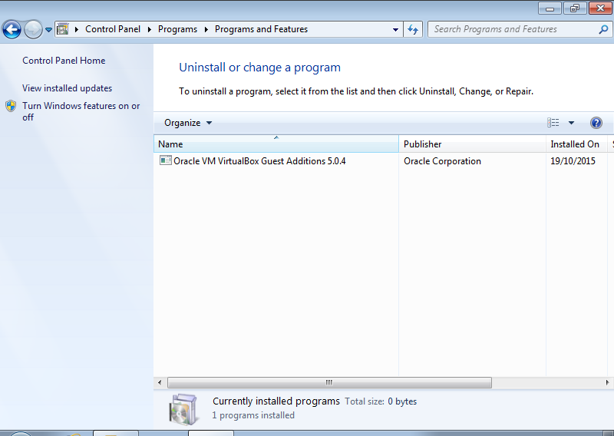
1.B VirtualBox Guest additions required to allow PrintScreen capture for the Host Machine

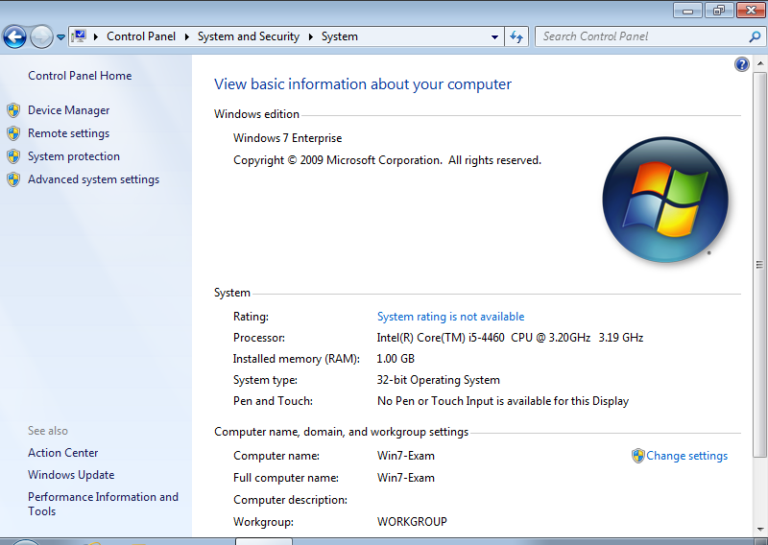
1.C Clean install of Windows 7 on Virtual Machine

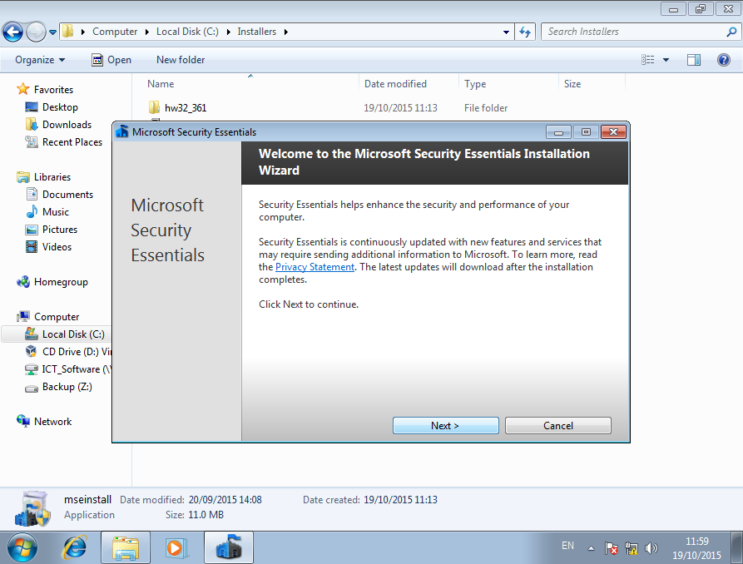
1.D Installation of Microsoft Security Essentials

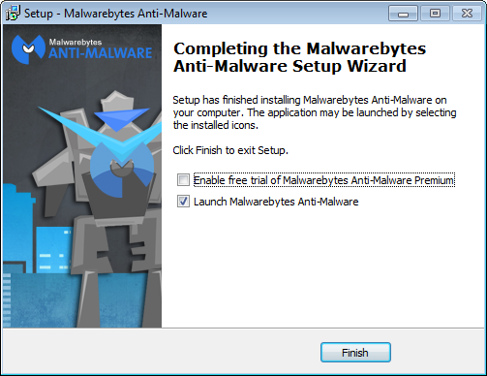
1.E Installation of Malwarebytes

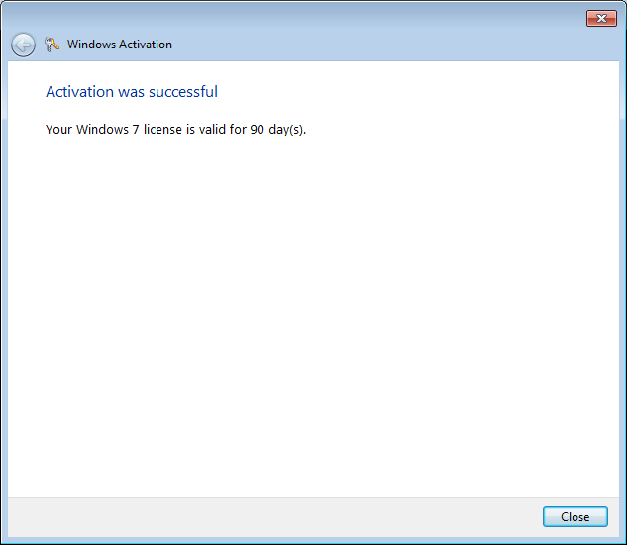
1.F Activated Windows 7 Evaluation
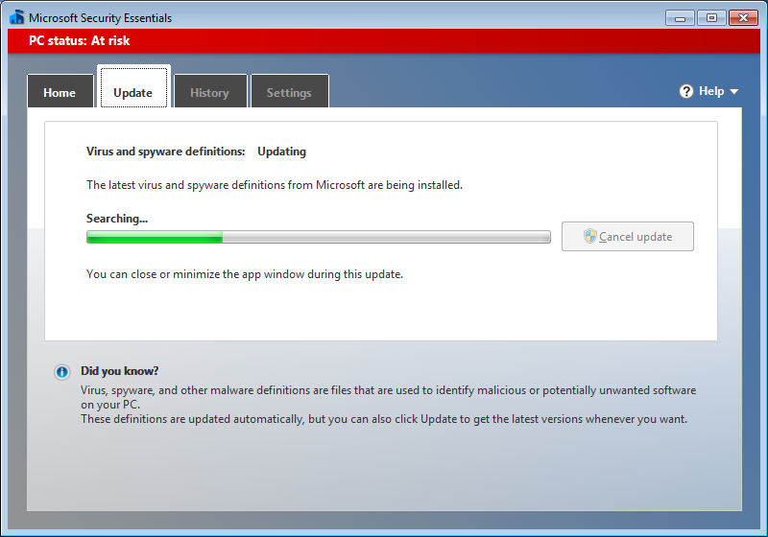
1.G Updated Microsoft Security Essentials Virus and Spyware definitions
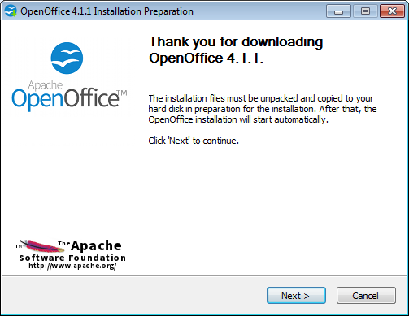
1.H Installed Apache Open Office as the Office solution

2 Configure the server to deploy automatically the software applications, provided by the Assessor, over the network. Transfer the installation files. This will most likely happen locally, and be under the Assessor’s instruction.
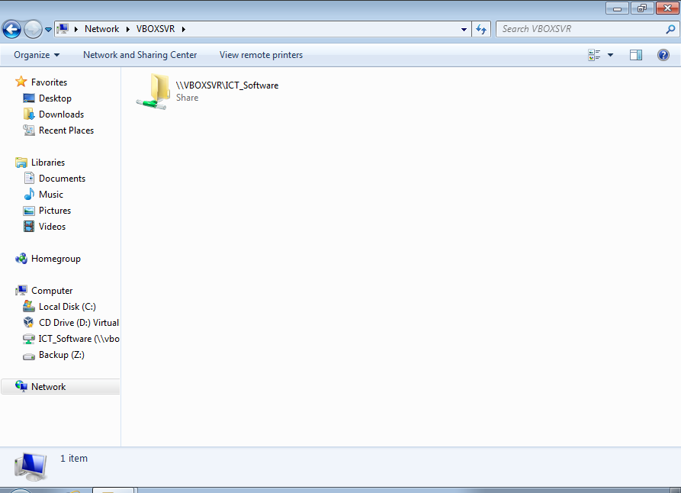
2.A Created Windows share between Host machine and Virtual Machine
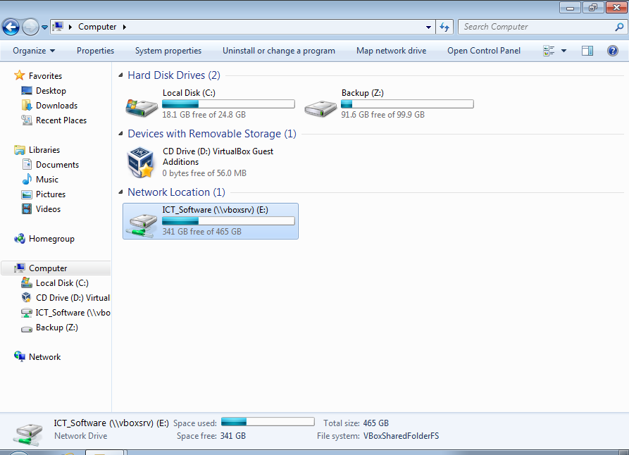 2.B Mapped network share to E:

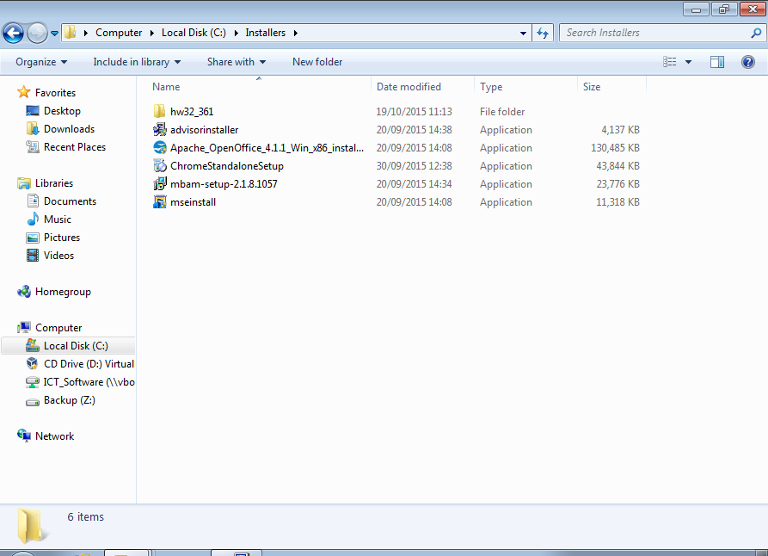
2.C Copied installers to c:\Installers on the Virtual Machine

3 Please use the Answer Sheet provided to complete Task B3.

Record the configuration settings of the automated deployment software.
- Set Virtual machine to Bridged adapter.
- Insert/Install VirtualBox Guest Additions
- Shared required software on Host Machine
- Navigated to the required software
- Created a permanent windows share to the software
- Copied the installers to the Virtual Machine
- Installed all software using default settings.

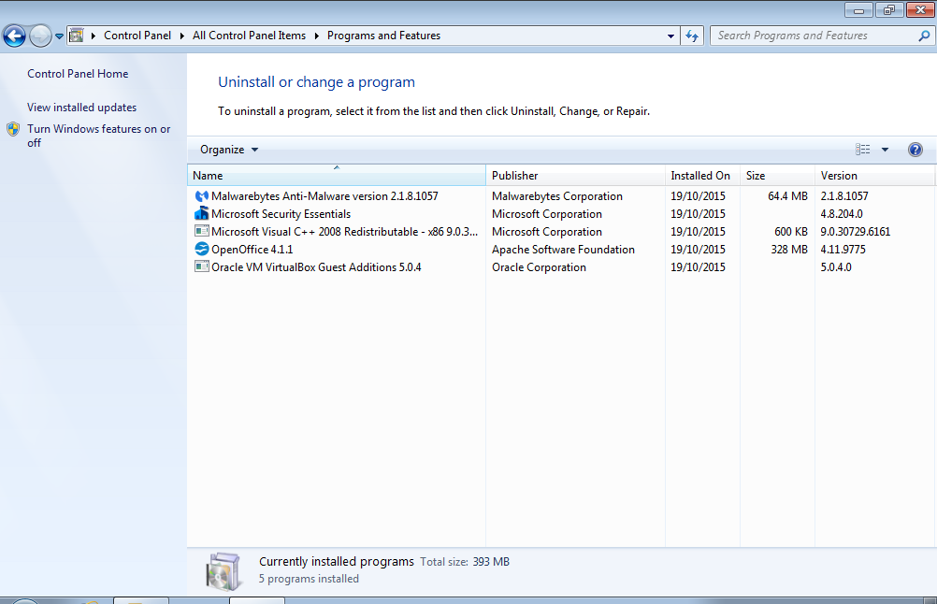
3.A All software installed successfully.

4 Following the installation plan you produced in Task A3, install each of the software applications and configure them as directed by the Assessor:
Software | Publisher | Title and Version | Configuration Settings
Office Suite | Apache | OpenOffice 4.1.1 | Default Settings
Anti-virus | Microsoft | Security Essential 4.8.204.0 | Default Settings
Anti-Malware | Malware Bytes | Malware Bytes 2.1.8.1057 | Default Settings

Please use the Answer Sheet provided to explain the difference(s) between an upgrade and a full installation of an operating system.
An upgrade of an operating system upgrades the existing operating system to the new version, while keeping all existing files and user permissions.
- Traditionally allows the user to keep all existing files.
- Requires that an existing and compatible Operating System is already installed.
- If the upgrade fails, it may require a full installation anyway.
- Traditionally the cheaper/easier option
A full installation of an operating system formats the existing operating system, and installs the new version from scratch.
- Requires the deletion of all existing files to ensure no Operating system is on the Computer
- More expensive
- More time consuming
- More difficult

5 Record the configuration details for each application.

Software | Publisher | Title and Version | Configuration Settings
Office Suite | Apache | OpenOffice 4.1.1 | Default Settings
Anti-virus | Microsoft | Security Essential 4.8.204.0 | Default Settings
Anti-Malware | Malware Bytes | Malware Bytes 2.1.8.1057 | Default Settings

6 Install any necessary upgrades/service packs for both Operating System and application software (Office Suite).
No upgrades necessary to both Operating System and Office Suite.
Updated Anti-virus and Anti-malware definitions list.

7 Monitor the installation of the software, identifying and recording any problems and resolutions.
7.A Installation of Microsoft Security Essentials

7.B Installation of Malwarebytes

7.C Installed Apache Open Office as the Office solution

No problems experienced.
No resolutions required.

8 Following the test plan you produced in Task A3, check each of the installed items of software and the OS for correct installation and operation. Record the results.
All items installed correctly and with no issues.

9 Download and install a second web browser using the default settings. (Install two different browsers if none already existed using default settings for each).
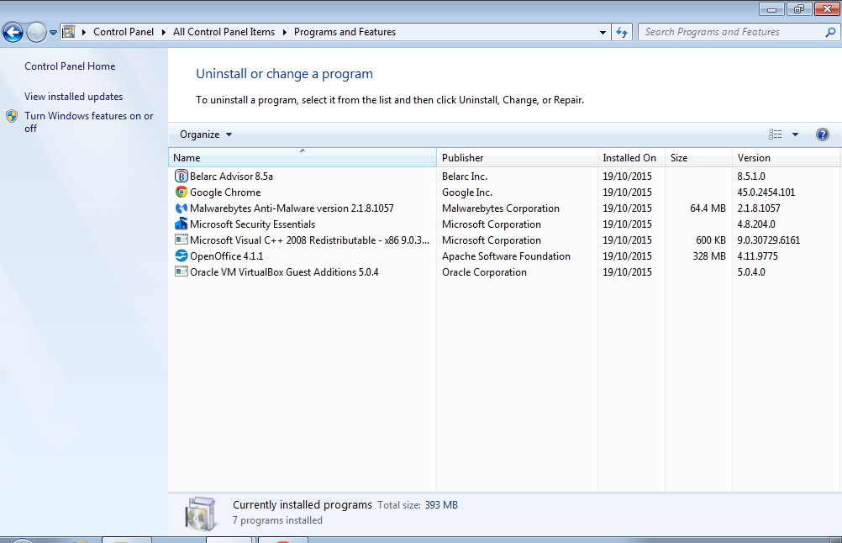
9.A Google Chrome installed successfully

10 Identify and document configuration changes made by the installation of the second browser.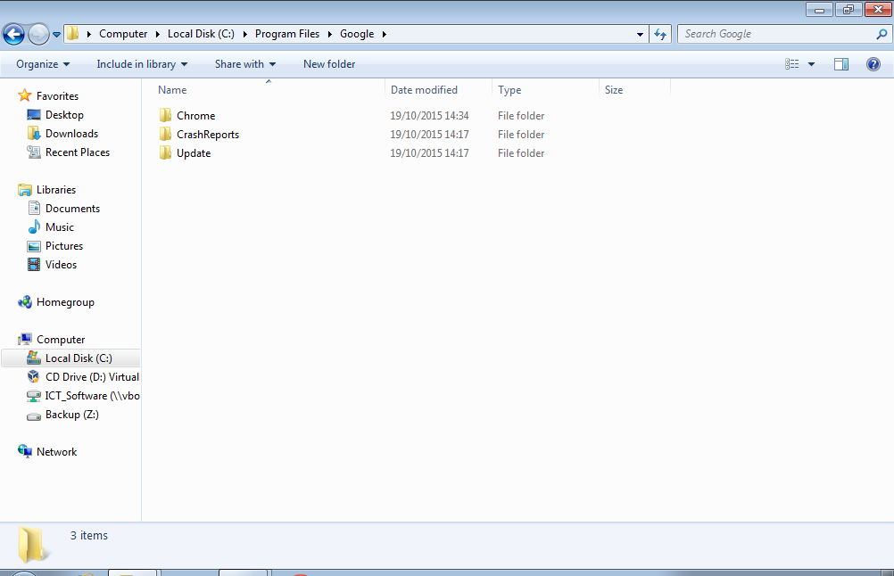
10.A New Chrome folder created in program files

11 Restore to the original settings any system and user configuration changes made by the second browser installation.

Record any changes made.

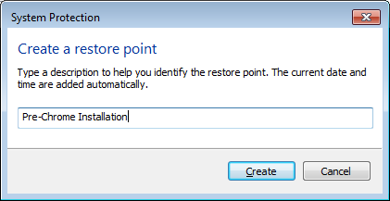
11.A Created a windows restore point prior to installing Google Chrome Browser
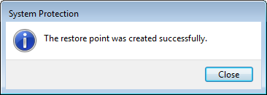
11.B Restore point created successfully.

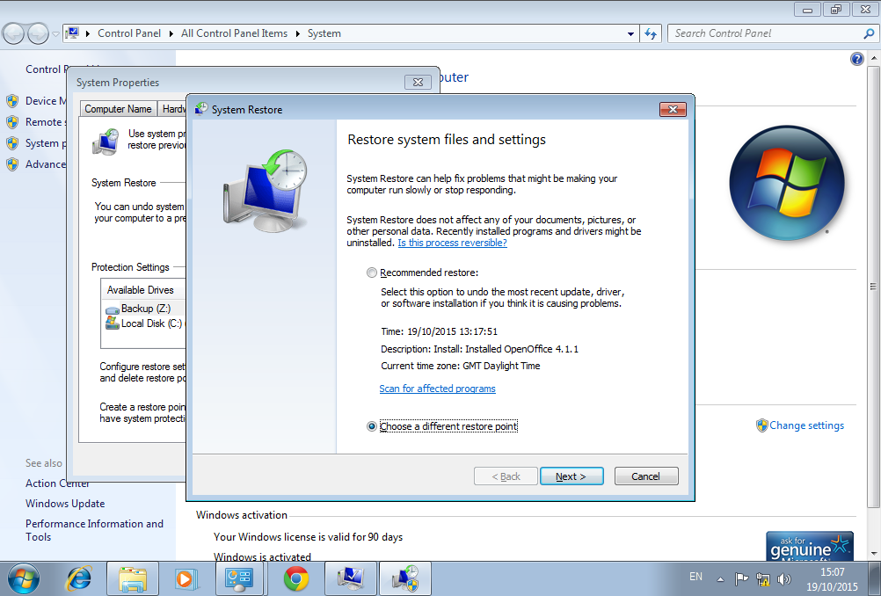
11.C Restore system files and settings (Note Chrome pinned to the task-bar)
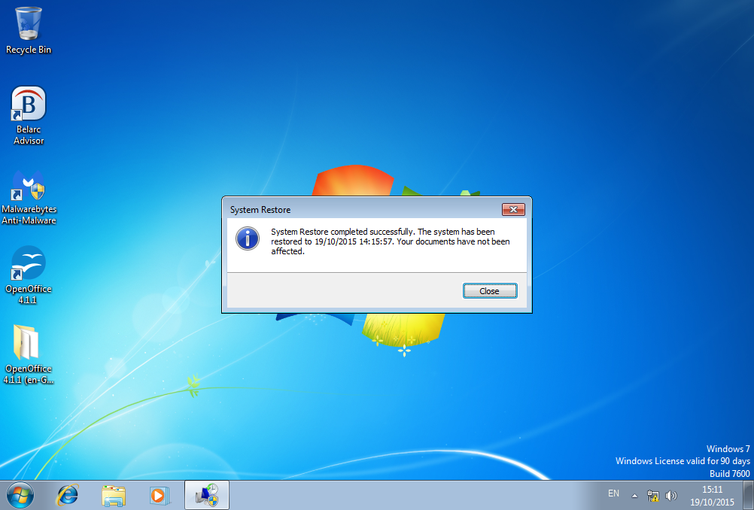
11.D Restored system to previous version (Note Chrome is no longer pinned to the task-bar)
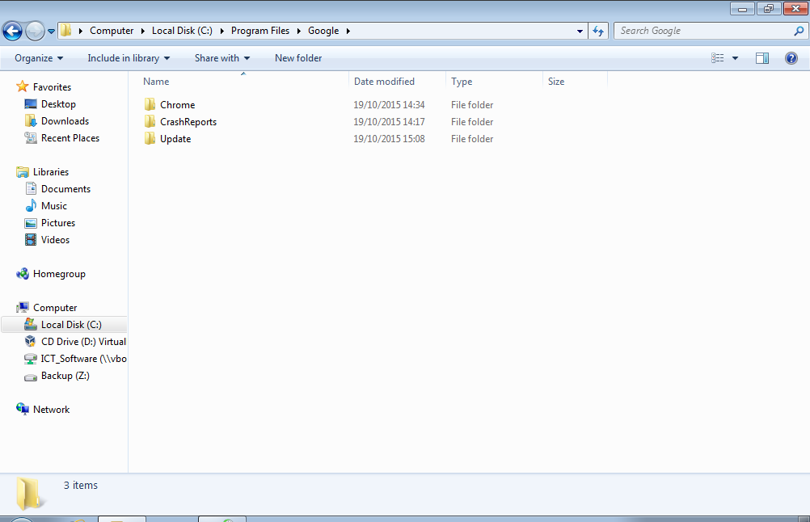
11.E Google Chrome folder still exists in Program Files

Task C – Collate installation records and knowledge questions

1 Assemble all of the records into one installation report, including any corrective actions you took.
Voila!

2 Please use the Answer Sheet provided to complete Task C2.

Identify how types of installation media affect installation processes and times.
Different types of installation media affect the installation processes and times in that depending on the media, it may take more time and/or have greater user input requirements. For example, when installing from DvD the read/access times are slower compared to Gigabit Lan (when performing a network installation) or USB 2.0 (when performing an installation from USB). In addition, network installations can create issues for other users due to the bandwidth required to copy all necessary files over the network to the required computer.

3 Please use the Answer Sheet provided to complete Task C3.

Explain the importance of protecting existing software and data.
It is important to protect existing software and data to ensure that user data is not deleted or
otherwise corrupted, as this loss of data may result in additional costs, mismanaged time and frustrated users. Protecting existing software is necessary to ensure the integrity of the installation; ensuring that all applications are available to all users again for similar reasons; to prevent additional costs, mismanaged time and frustrated users.

4 Please use the Answer Sheet provided to complete Task C4.

When installing software applications, give three reasons why it may be necessary to use a ‘custom’ location for the files instead of the default one and explain the difference between a full installation of software and a custom installation.
It may be necessary to use a custom location for files instead of the default one for the following reasons:
- Due to main partition not being large enough for the installation
- Due to additional organisational requirement i.e. operating system on C:, programs on D:
- Installing to a shared folder

5 Please use the Answer Sheet provided to complete Task C5.

Explain the difference between registering propriety software against that of registering freeware or shareware software.
The main difference between registering propriety software against that of registering freeware/shareware software is that propriety software traditionally provide additional services and notifications to their users; while freeware/shareware software does not.

6 Please use the Answer Sheet provided to complete Task C6.

Explain why it is important to maintain accurate records of installations.
It is important to maintain accurate records of installations to ensure that all software is consistently provided to all existing and future installations. These accurate records may also make it significantly easier for the user to determine any software conflicts.

7 Please use the Answer Sheet provided to complete Task C7.

Explain how effective and timely installation of approved software could improve customer satisfaction.
Effective and timely installation of approved software could improve customer satisfaction as provides consistency in employee interactions with customers; as all employees are utilising the same software.

